**DATA INSERTION**

1. **CUSTOMER:** – insert customer record in CustomerDB

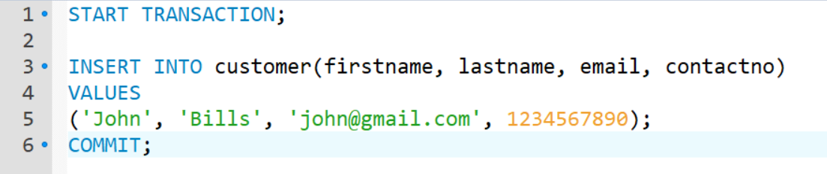

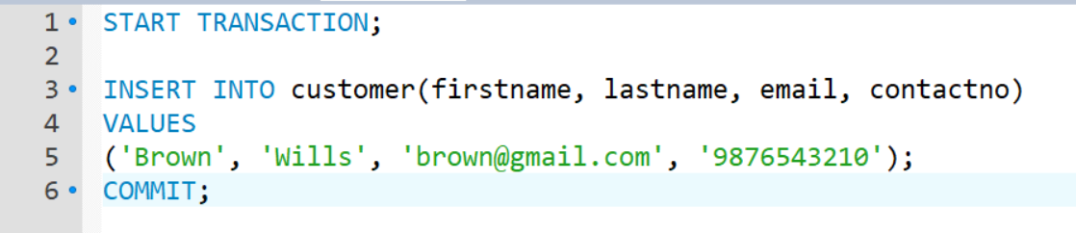

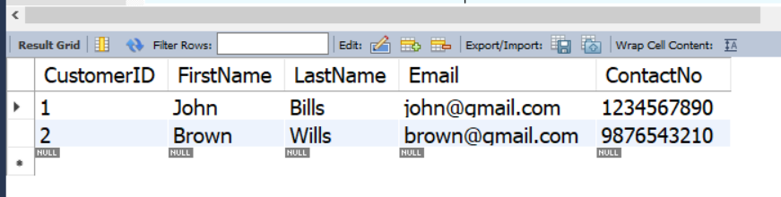

1. **CUSTOMER ADDRESS:** – customer can insert multiple address at a time

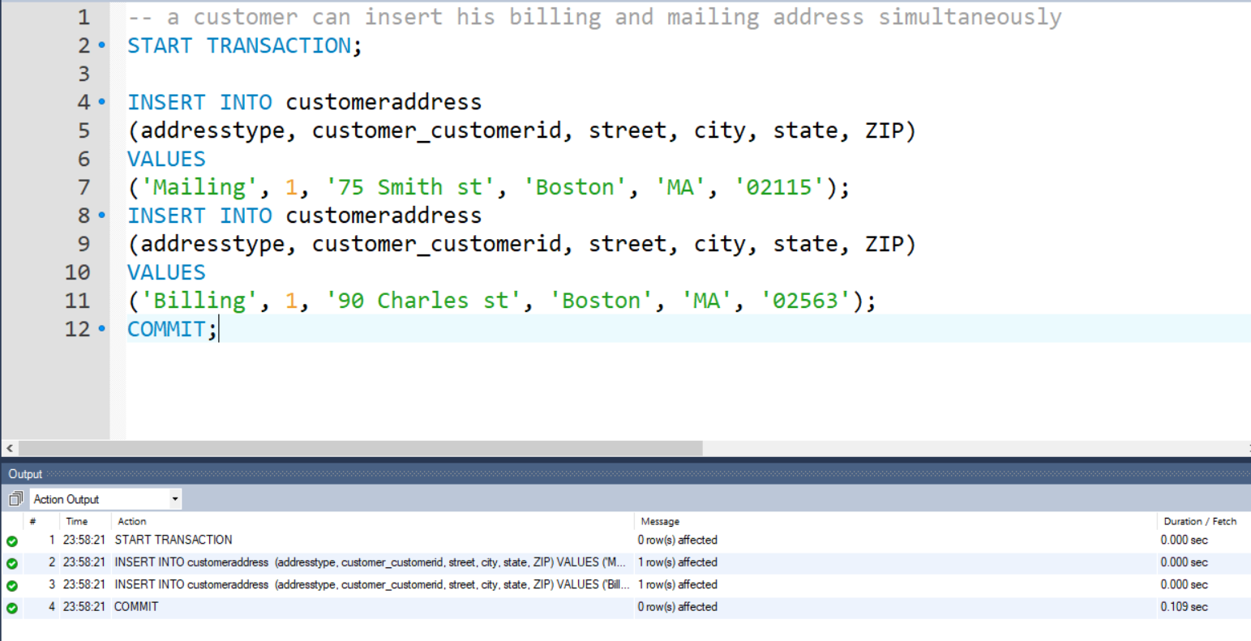

Another customer adds his own address data

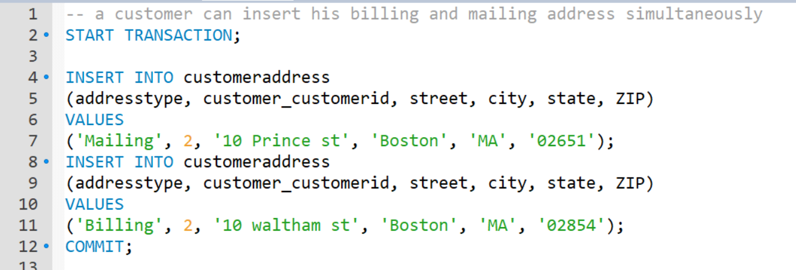

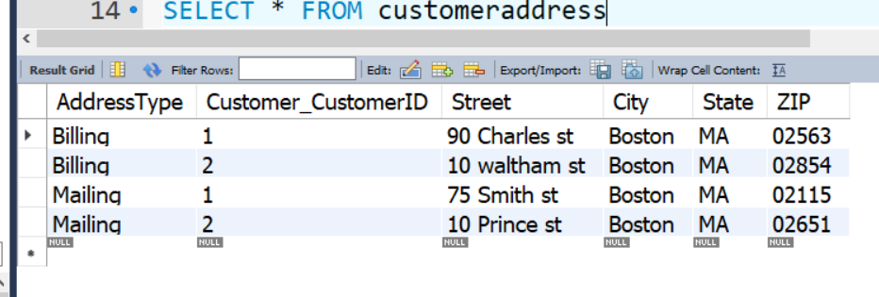

1. **GIFT CARD:** – a customer can insert 1 or multiple gift cards into his account

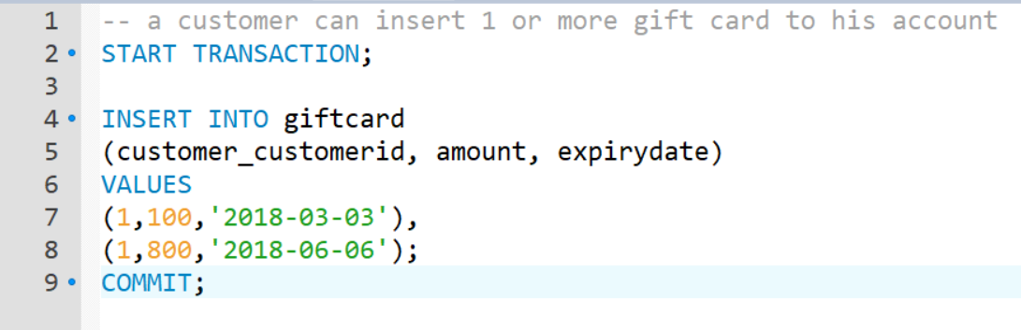

Same is done for other customers as well and below is the output.

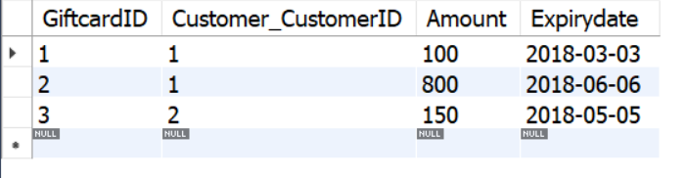

1. **CREDIT CARD:** – a customer can add 1 or more credit cards in his account

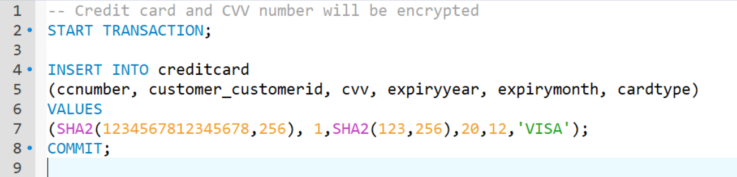

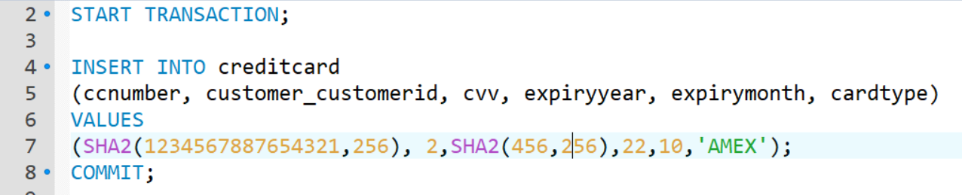

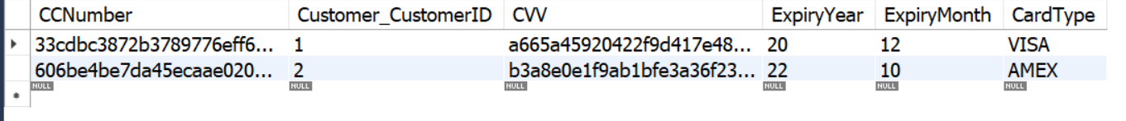

1. **SUPPLIER:** – create suppliers

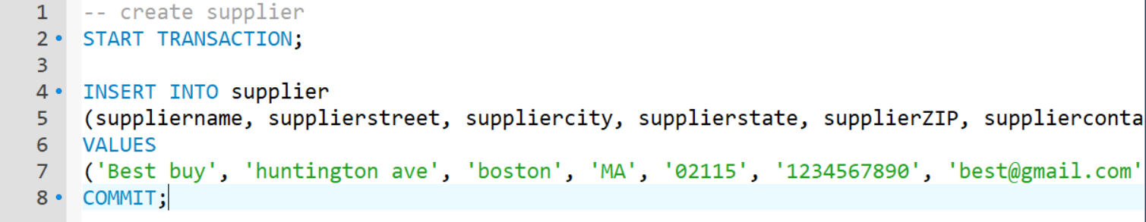

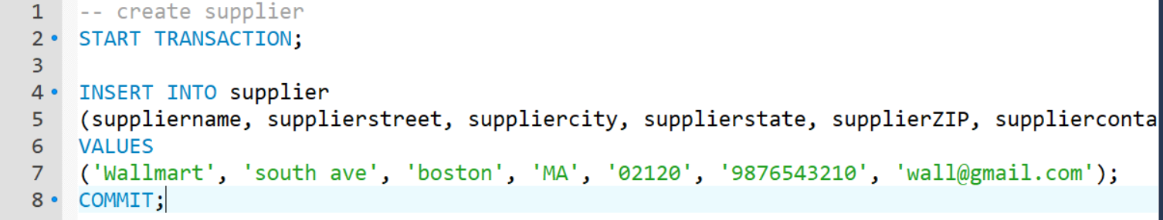



1. **PRODUCT:** – supplier can add many products at a time

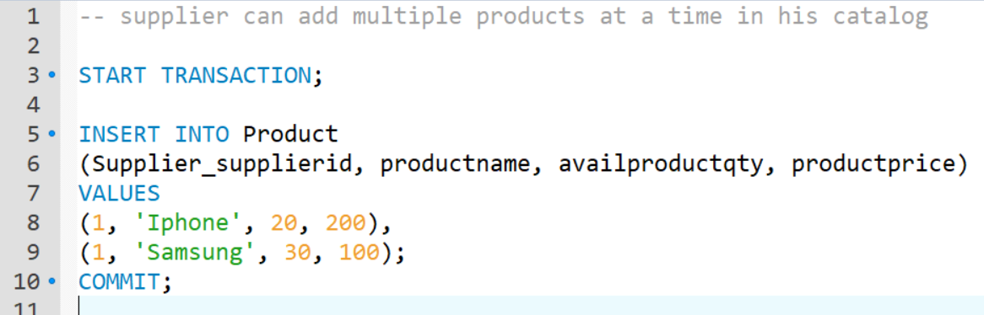

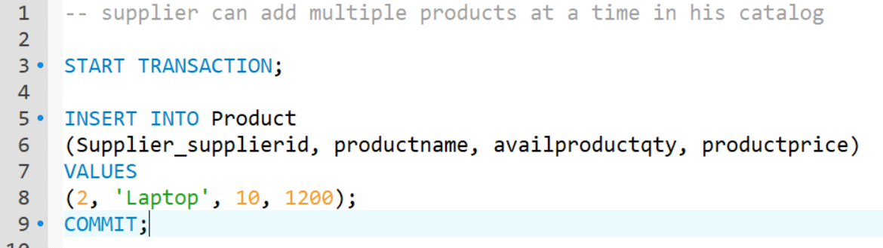

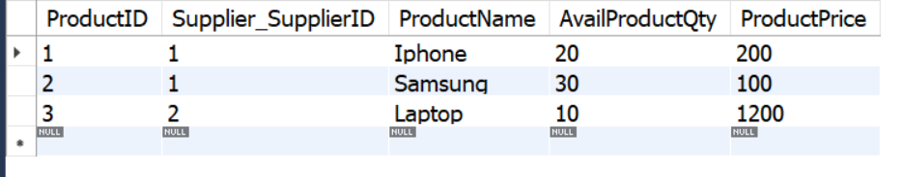

1. **PRODUCT DISCOUNT:** – supplier can add 0 or multiple products at a time

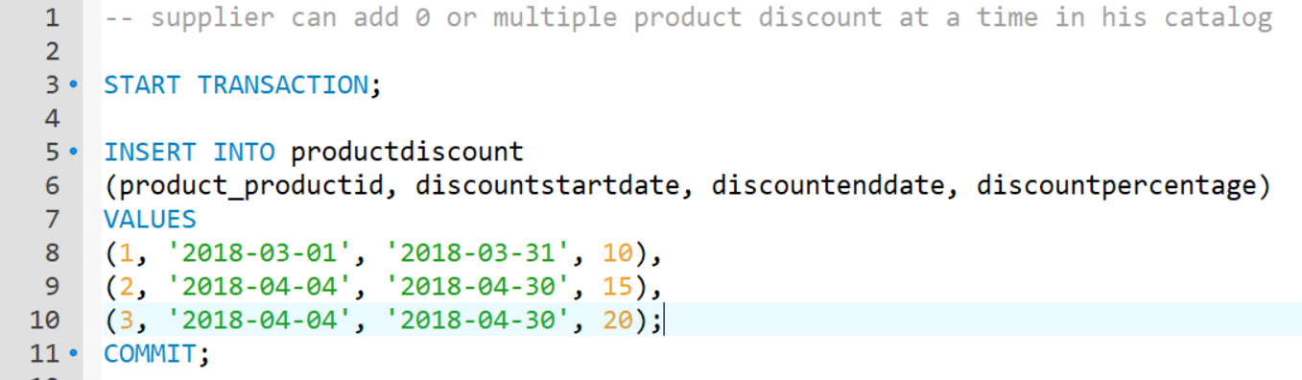

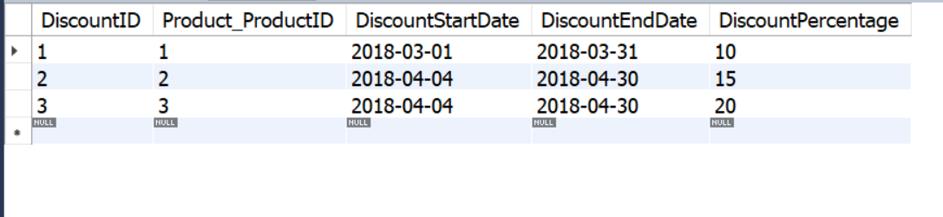

1. **WAREHOUSE:** – at a time only 1 warehouse will be added

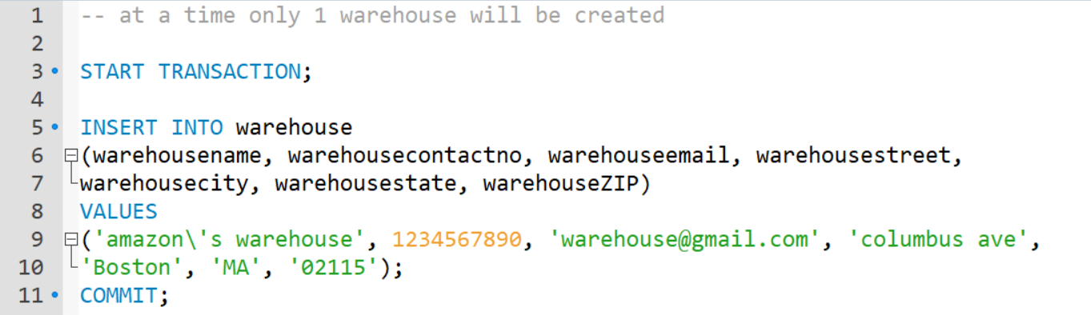



1. **DELIVERY PROVIDER:** - at a time many delivery providers can be created

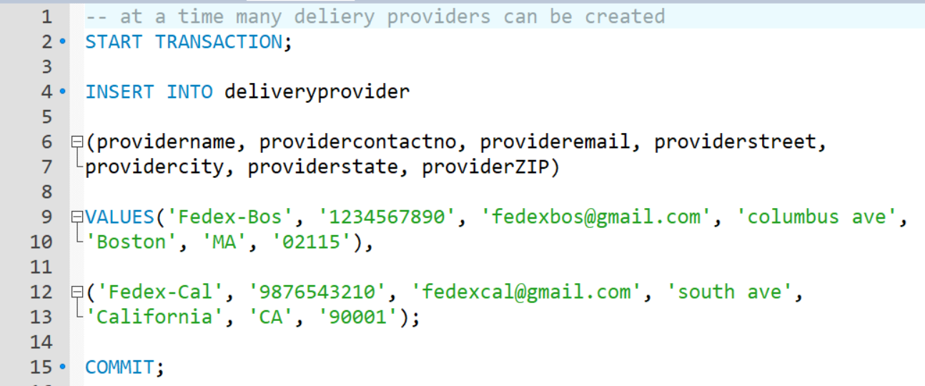



1. **PURCHASE ORDER:** – a customer can create 1 order at a time (at the time of PO creation, customer will create multiple order items and 1 Invoice as well)

Here customerID = 1 places an order

Before creating PO – below are the available product quantity

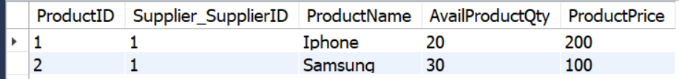

PO is created (along with Order items and Invoice)

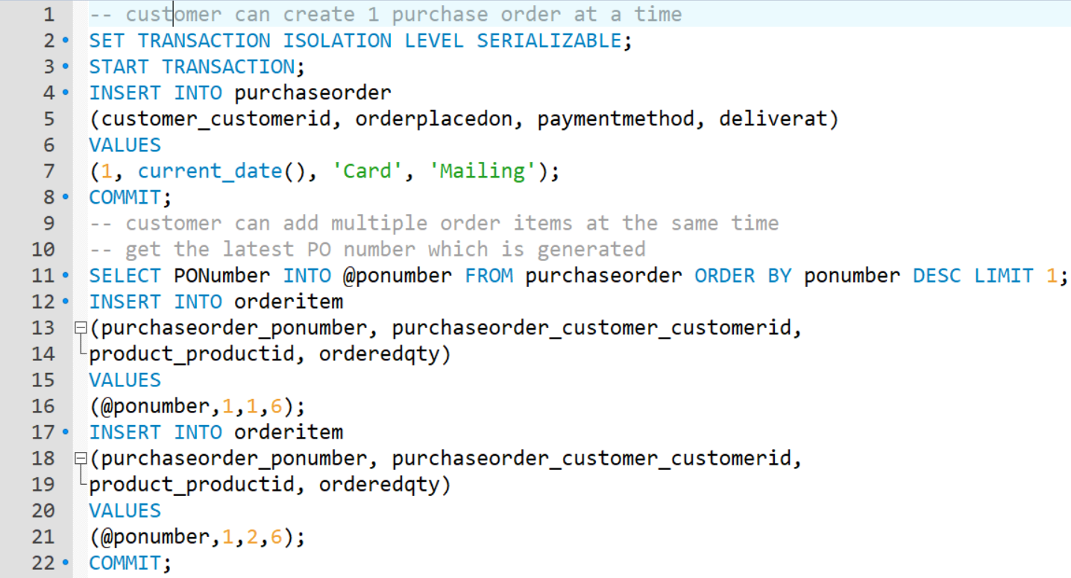

* Single invoice will be created per purchase order per customer

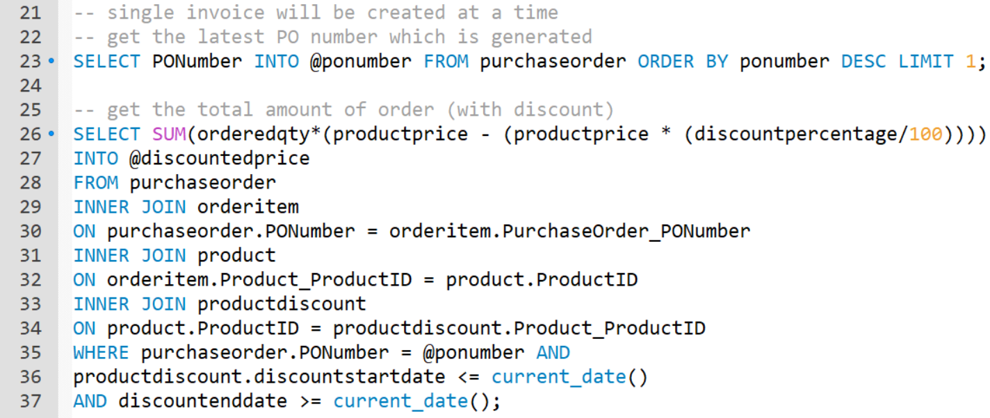

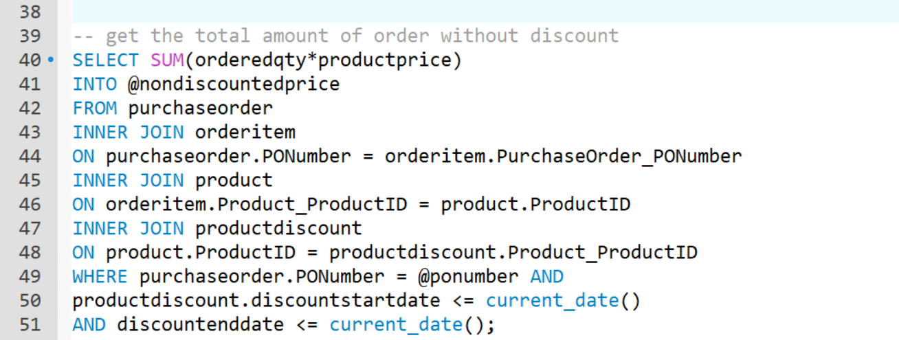

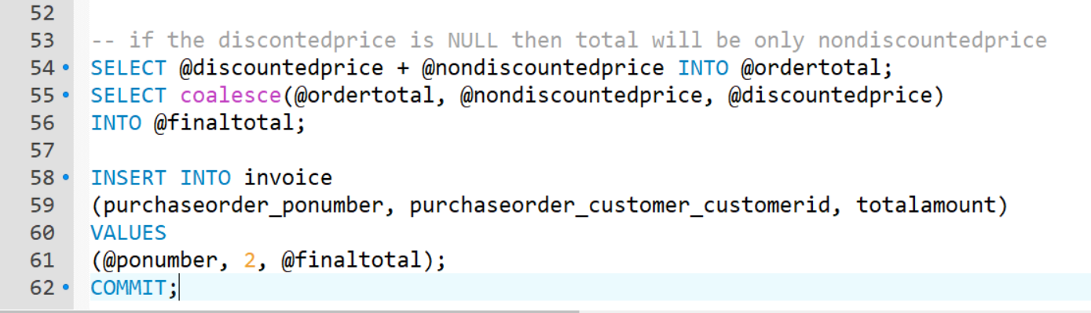

PO is created



‘Multiple order items are created



**Product quantity will be reduced from product table**

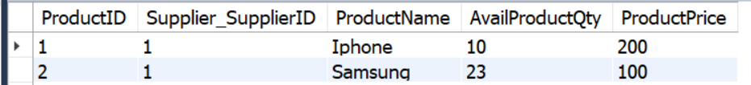

Single invoice will be created (where total price of invoice will include Active product discounts as well)

Shipping speed will be 1day since the order amount is greater than 1000



Customer can give rating to products which he has ordered (from his PO)

(However, PO number and OrderitemID needs to be manually provided)

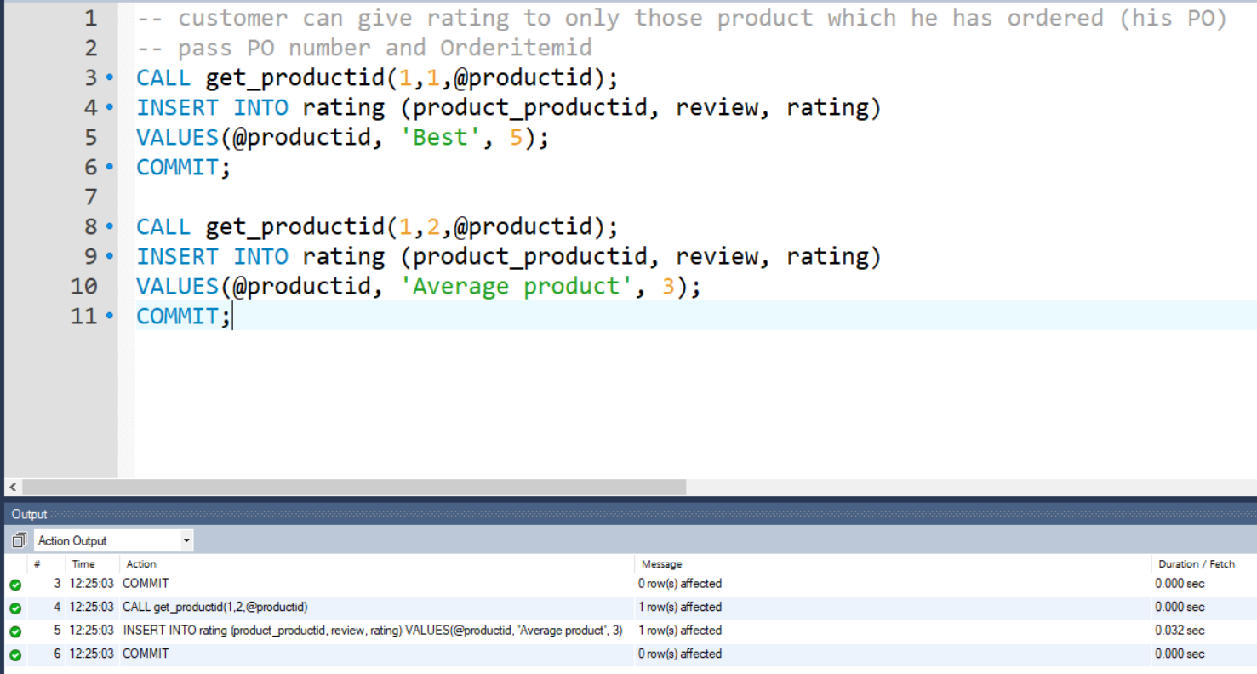

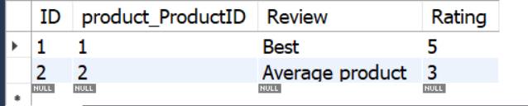

**Now customer 1 places another order**

Before creating PO – below are the available product quantity

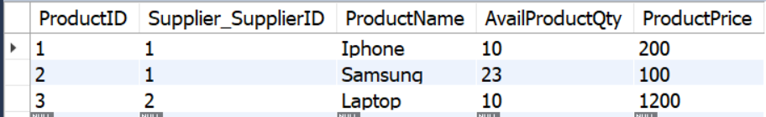

PO is created (along with Order items and Invoice)

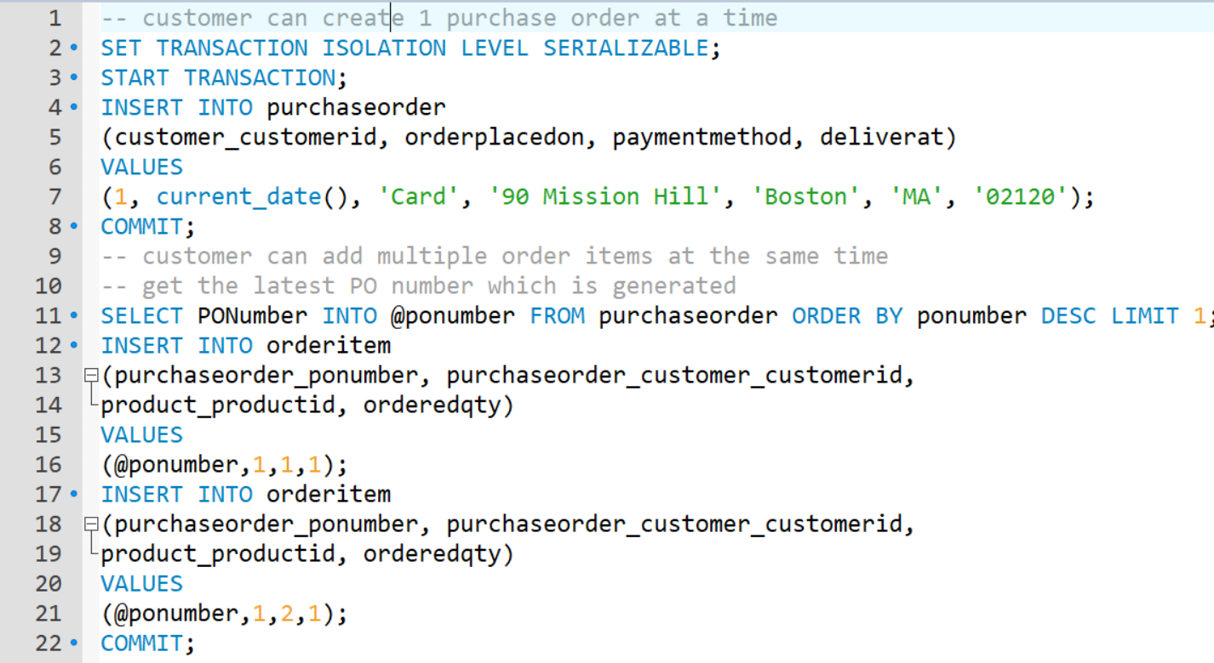

Single invoice will be created

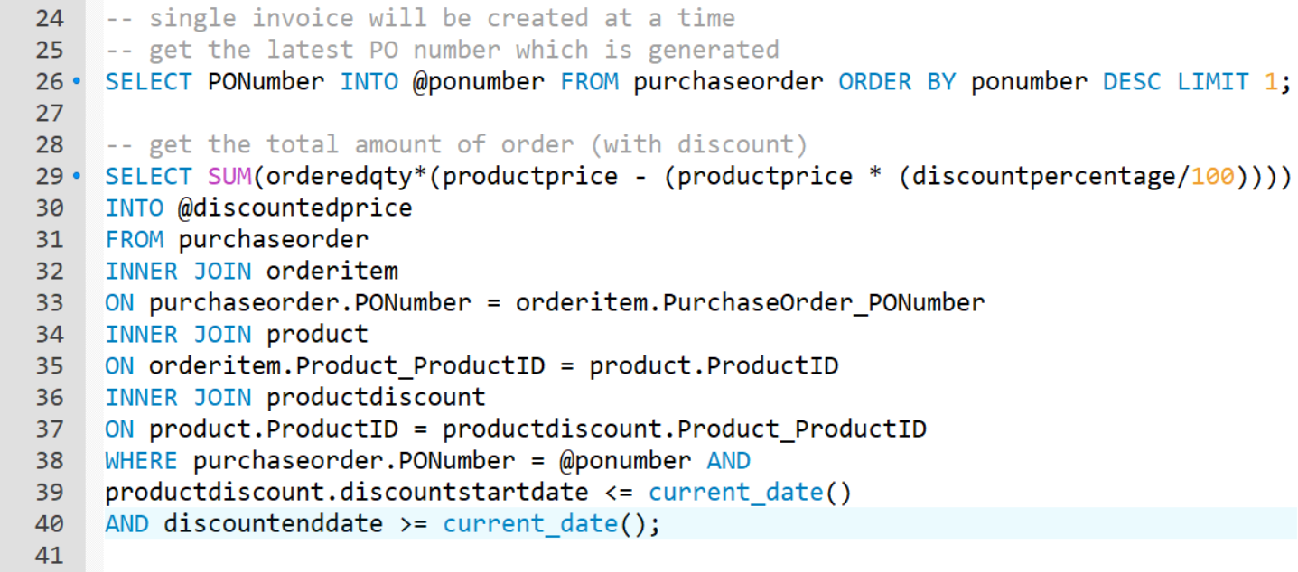

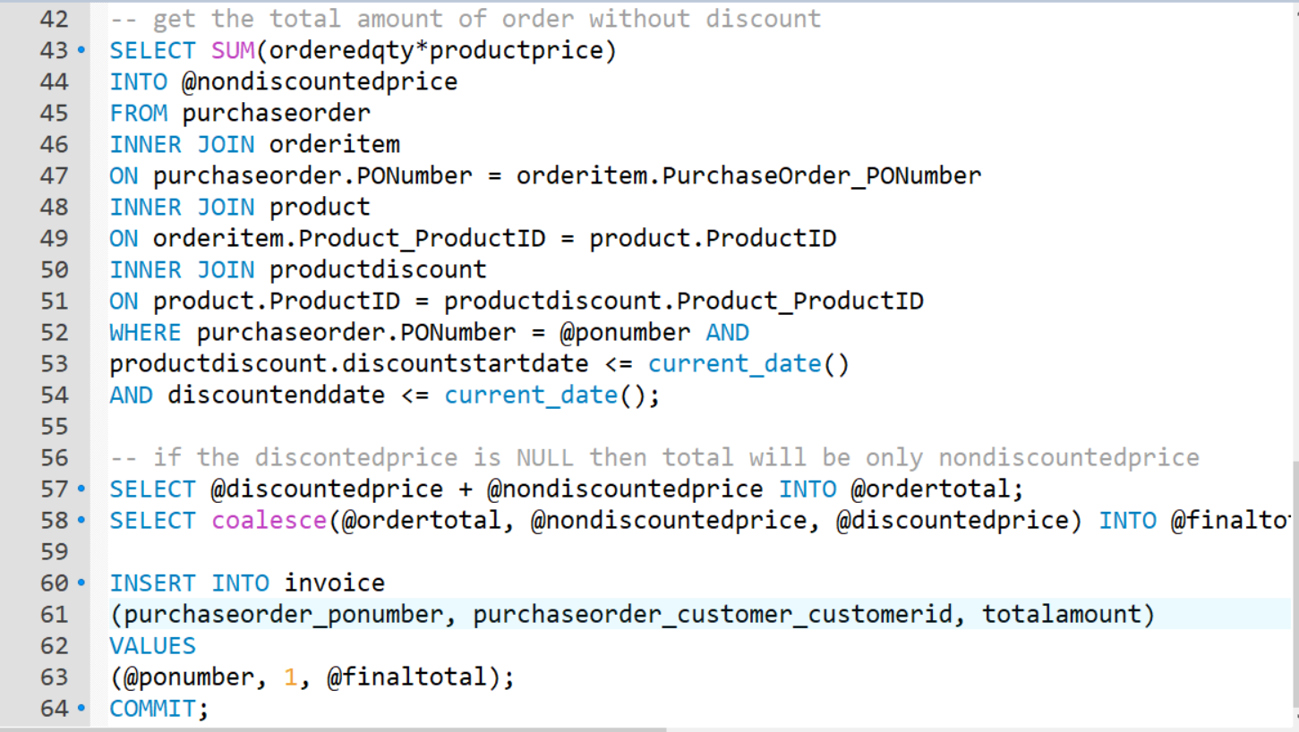

PO is created (POnumber = 2)



‘Multiple order items are created



**Product quantity will be reduced from product table (1 each from productid 1 & 2)**

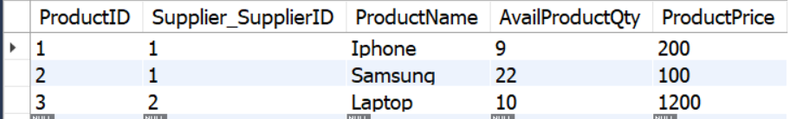

Single invoice will be created (where total price of invoice will include Active product discounts as well)



Shipping speed will be normal since the order amount is less than 500.

Customer can give rating to those products which he has ordered (from his PO)

(However, PO number and Orderitemid needs to be manually provided to procedure ‘give_rating

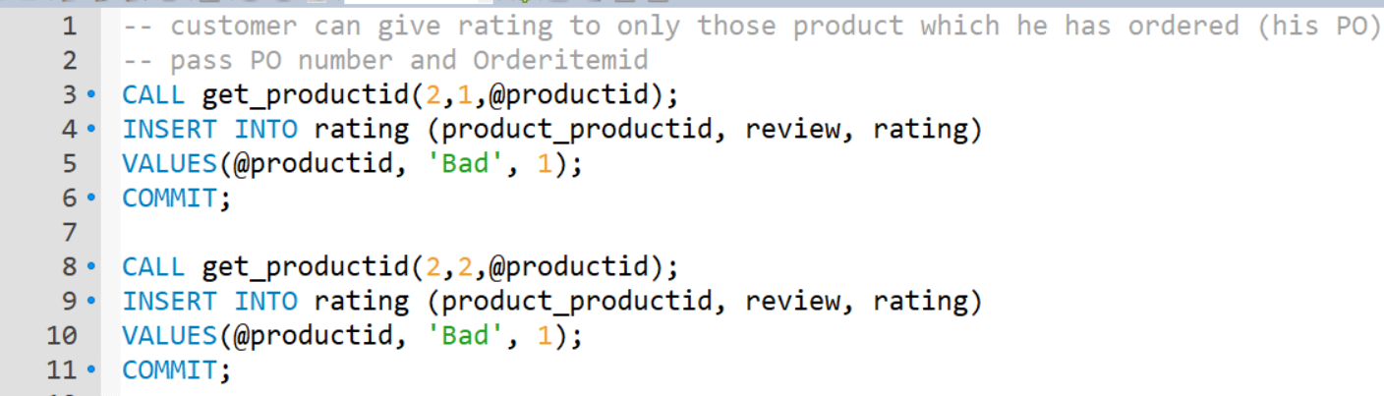

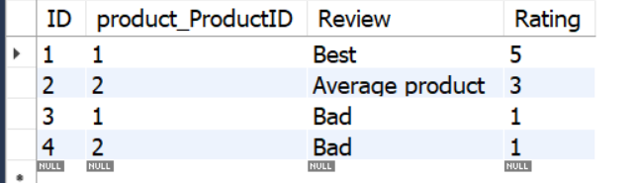

1. **SHIPMENTS:** – Warehouse will prepare shipments

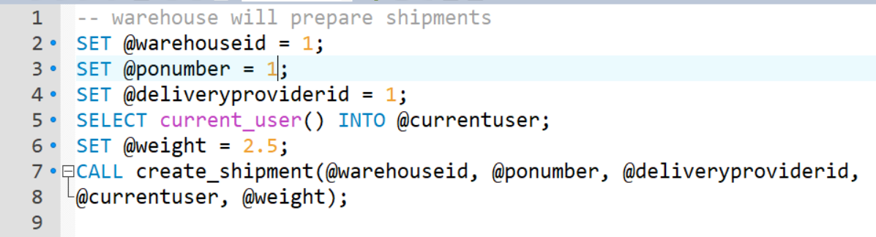



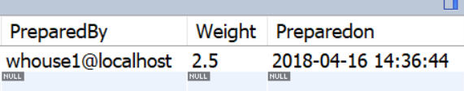

Warehouse now will prepare another shipment (shipment = 2)

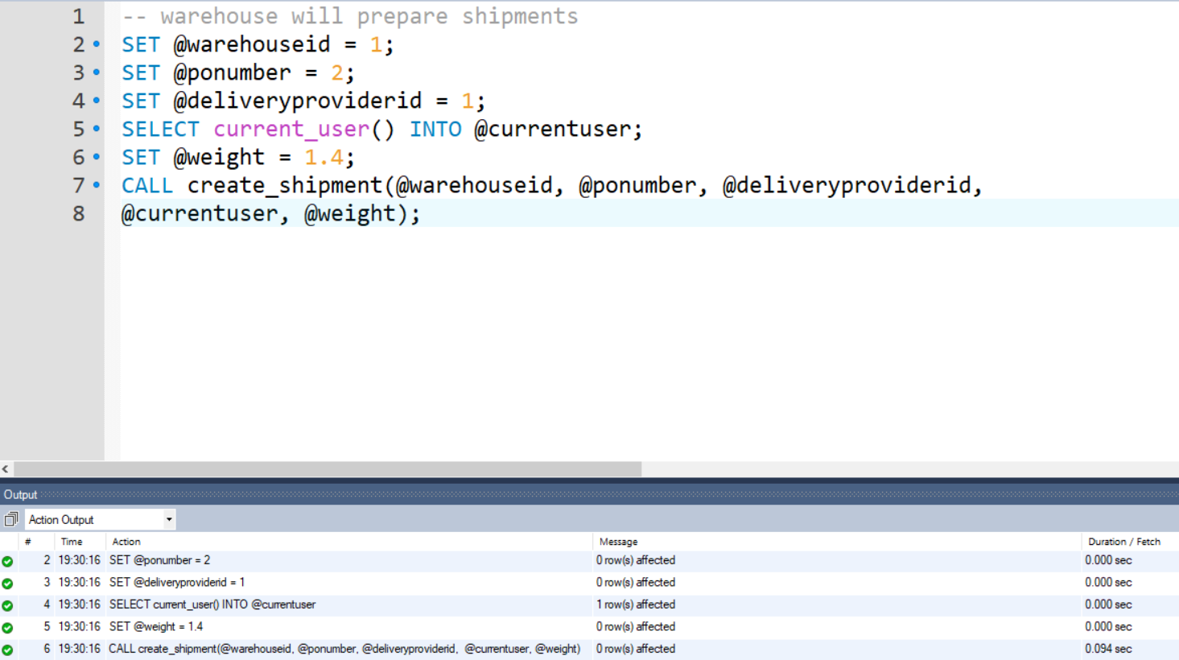



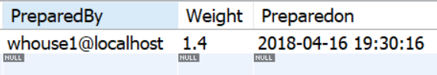

1. **TRACKING:** – delivery provider will create tracking number and assign shipment to it

Delivery provider will now create the tracking for given shipment

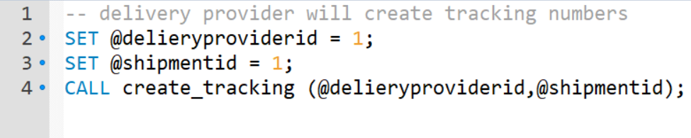

Tracking number is created and shipment is assigned to the tracking



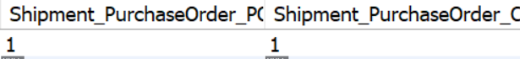

Order status has now changed to Shipped



Now another shipment is created for shipment ID 2

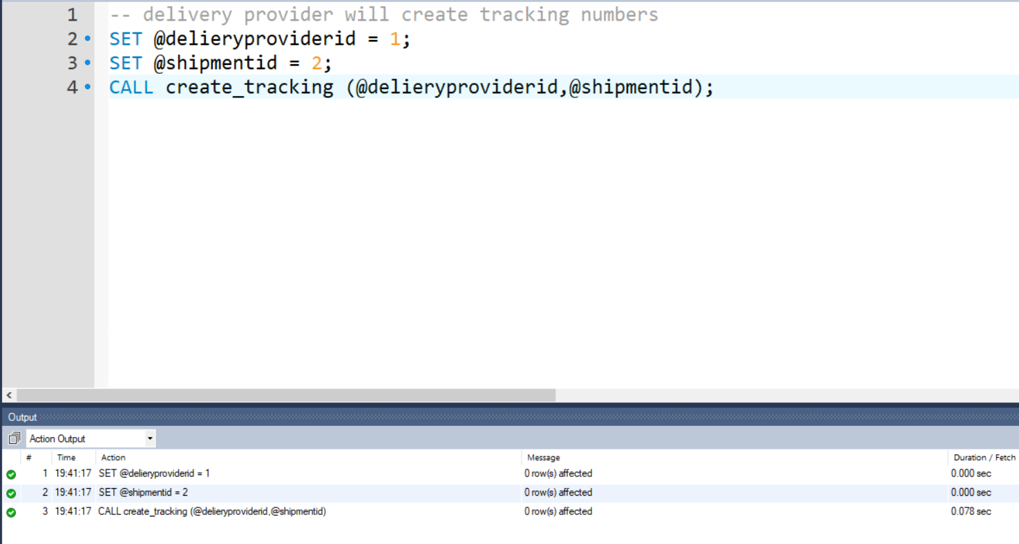

Before the tracking is created for given shipment/PO, PO status will be placed



Tracking number 3 is generated



Once the tracking number is created, order status will be changed to ‘Shipped’



1. **TRACKINGSTATUS:** – delivery provider will create multiple tracking status containing shipment

If tracking status’s state and ZIP matches with the PO’s state and ZIP then order status of given PO will be changed to Delivered.

Current PO(1) has state MA and ZIP as 02115



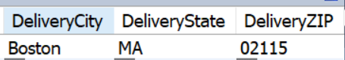

Create tracking status

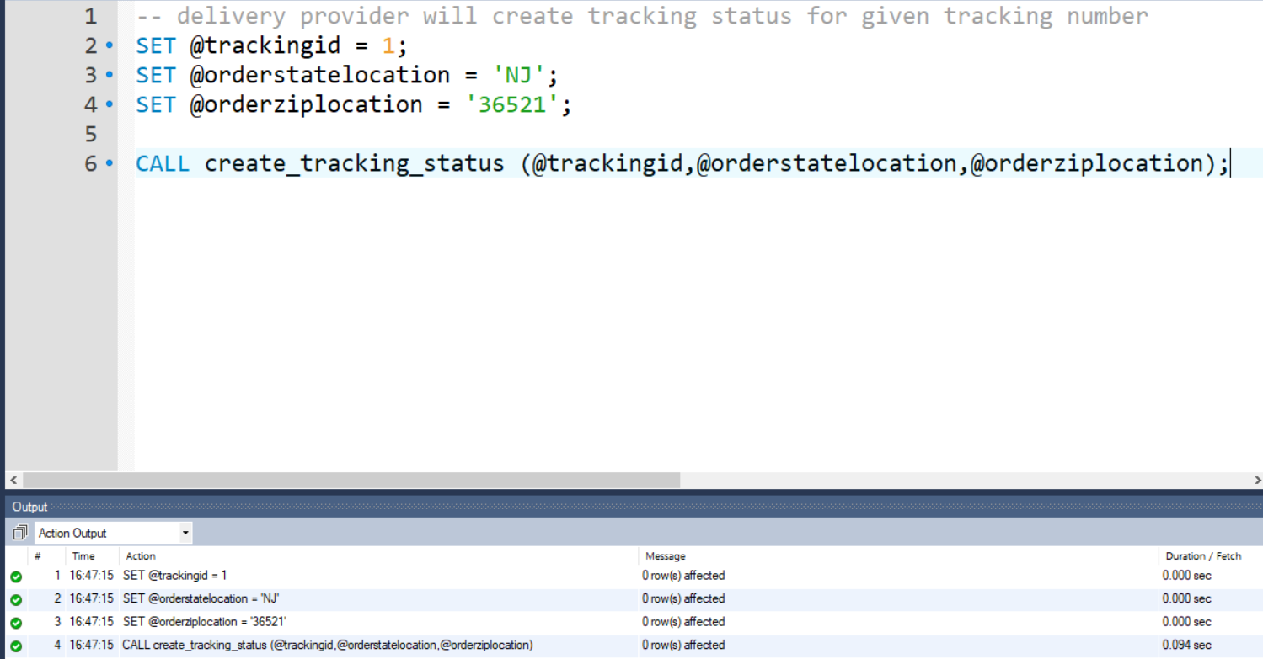



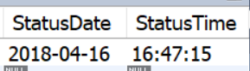

PO order status remains unchanged



Enter 1 more tracking status of given shipment

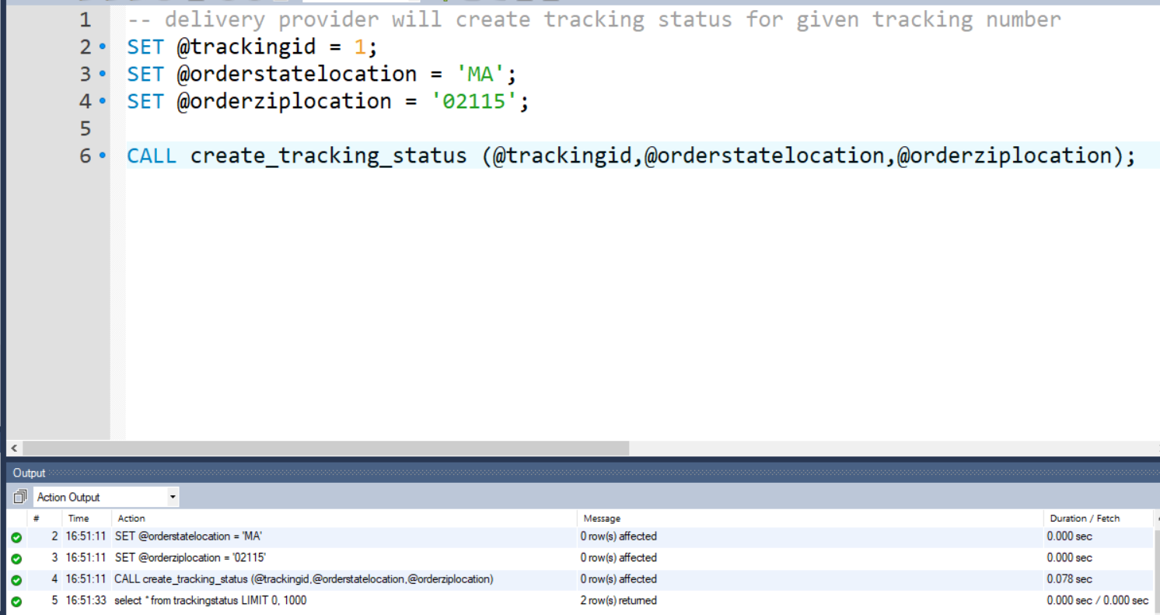



Now since the tracking status is at MA location and 02115 which matches PO’s state and ZIP, purchase order’s status will be changed to delivered.



Same procedure for Tracking – 3, Shipment 2 and PO – 2

delivery provider will create multiple tracking status containing shipment

Current PO(2) has state MA and ZIP as 02115



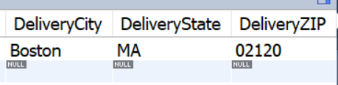

Create tracking status for Trackingid = 3

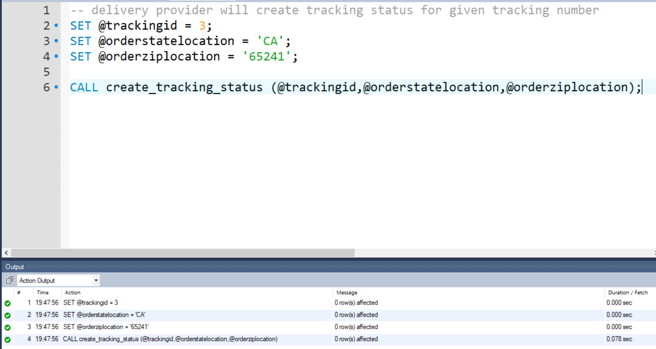



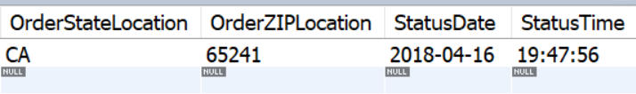

PO order status remains unchanged



Enter 1 more tracking status of given shipment

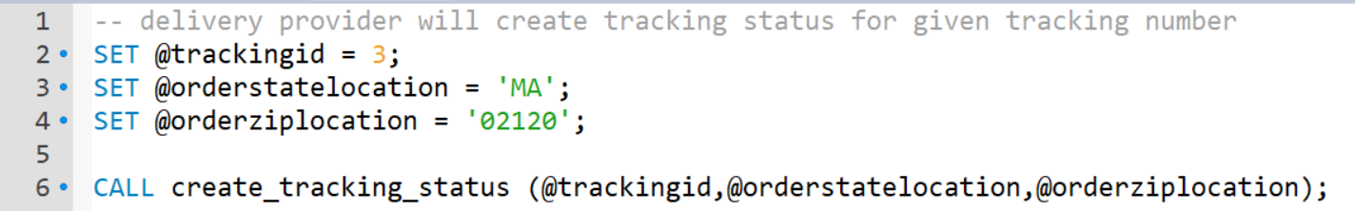



Now the order status will be changed to Delivered.

